http://www.dotnettricks.com/learn/oops/object-oriented-programming-concepts:
Object-Oriented Programming Concepts (www.dotnettricks.com)
Author : Shailendra Chauhan
Posted On : 15 Feb 2011
Updated On : 10 Jul 2012

Object-Oriented Programming Concepts
OOP is a design philosophy. It stands for Object Oriented Programming. Object-Oriented Programming (OOP) uses a different set of programming languages than old procedural programming languages (C, Pascal, etc.). Everything in OOP is grouped as self-sustainable "objects". Hence, you gain re-usability by means of four main object-oriented programming concepts. Below are object oriented programming concepts:
- Object
Object is representative of the class and is responsible for memory allocation of its data members and member functions. An object is a real world entity having attributes (data type) and behaviors (functions).
An object can be considered a "thing" that can perform a set of related activities. The set of activities that the object performs defines the object behavior. For example, the hand can grip something or a Student (object) can give the name or address
- Class
Class is a data structure that contains data members (constants files, events), member function methods, properties, constructor, destructor, indexers and nested type. Basically
  - It is a user defined data type.
  - It is a reference type.
  - Infact class is a tag or template for object.
- Encapsulation
Encapsulation is a mechanism of binding the data member & member function into a single unit known as class. Encapsulation provides a way for abstraction. In OOP the encapsulation is mainly achieved by creating classes, the classes expose public methods and properties. The class is kind of a container or capsule or a cell, which encapsulate the set of methods, attribute and properties to provide its indented functionalities to other classes.
- Data abstraction
Data abstraction is a mechanism to provide the essential features without describing the background details. Means provide the functions to access the hidden (private) data.
The importance of abstraction is derived from its ability to hide irrelevant details and from the use of names to reference objects. Abstraction is essential in the construction of programs. It places the emphasis on what an object is or does rather than how it is represented or how it works. Thus, it is the primary means of managing complexity in large programs.
- Data Hiding
Data hiding is a mechanism to hide the internal structure of an object from rest of the program. In a class private members are hidden from the rest of the program, hence it supports data hiding. Data hiding is also a way to implement data abstraction.
- Polymorphism
Polymorphism means one thing in many forms. Basically polymorphism is capability of one object to behave in multiple ways. Example: A man role changes at home, college, and outside the home. There are following types of polymorphism:
  - Static polymorphism (compile time): It is achieved using function overloading and operator overloading.
  - Dynamic polymorphism (runtime time): It is achieved using function overriding means using virtual function.

Difference between function and method
In programming langauages we have two concepts: functions and methods. functions are defined in structural language and methods are defined in object oriented langauge. The difference between both is given below :

Functions
- Functions have independent existence means they can be defined outside of the class. Ex:- main() function in C, C++ Language
- Functions are defined in structured languages like Pascal, C and object based language like javaScript
- Functions are called independently.
- Functions are self describing unit of code.

- //function main in C
- void main()
- {
- int a,b,c;
- a=5;
- b=6;
- c=a+b;
- printf("Sum is : %d",c);
- }

Methods
- Methods do not have independent existence they are always defined with in class. Ex:- main() method in C# Language that is defined with in a class
- Methods are defined in object oriented languages like C#, Java
- Methods are called using instance or object.
- Methods are used to manipuate instance variable of a class.
- //method sum in C#
- class demo
- {
- int a,b,c;
- public void sum()
- {
- a=5;
- b=6;
- c=a+b;
- Console.WriteLine("Sum is : {0}",c);
- }
- }

Difference between object oriented and object based languages
Object oriented and Object based programming languages have some different features and behaviour. In this article, I am going to expose the main difference between these two programming languages.

Object oriented language
- Object-oriented language supports all the features of OOPs.
- Object-oriented language doesn't has in-built object.
- Object-oriented languages are C++, C#, Java etc.

Object based language
- Object-based language doesn't support all the features of OOPs like Polymorphism and Inheritance
- Object-based language has in-built object like javascript has window object.
- Object-based languages are Javascript, VB etc.

Summary
In this article I try to expose the difference between object oriented and object based languages . I hope after reading this article you will be able to diffrentiate between these two languages. I would like to have feedback from my blog readers. Please post your feedback, question, or comments about this article.

Understanding Association, Aggregation, Composition and Dependency relationship
A relationship defines the connection between objects. This explains how objects are connected to each other’s and how they will behave.

Association
It represents a relationship between two or more objects where all objects have their own lifecycle and there is no owner. The name of an association specifies the nature of relationship between objects. This is represented by a solid line.
Let’s take an example of relationship between Teacher and Student. Multiple students can associate with a single teacher and a single student can associate with multiple teachers. But there is no ownership between the objects and both have their own lifecycle. Both can be created and deleted independently.


Aggregation
It is a specialized form of Association where all object have their own lifecycle but there is ownership. This represents “whole-part or a-part-of” relationship. This is represented by a hollow diamond followed by a line.
Let’s take an example of relationship between Department and Teacher. A Teacher may belong to multiple departments. Hence Teacher is a part of multiple departments. But if we delete a Department, Teacher Object will not destroy.


Composition
It is a specialized form of Aggregation. It is a strong type of Aggregation. In this relationship child objects does not have their lifecycle without Parent object. If a parent object is deleted, all its child objects will also be deleted. This represents “death” relationship. This is represented by a solid diamond followed by a line.
Let’s take an example of relationship between House and rooms. House can contain multiple rooms there is no independent life of room and any room cannot belongs to two different house if we delete the house room will automatically delete.
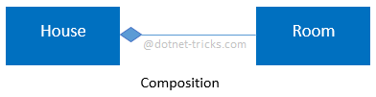
Let’s take another example of relationship between Questions and options. Single questions can have multiple options and option cannot belong to multiple questions. If we delete questions options will be automatically deleted.

Dependency
It represents a relationship between two or more objects where an object is dependent on another object(s) for its specification or implementation. This is represented by a dashed arrow.
Let’s take an example of relationship between client and service. A client is dependent on the service for implementing its functionalities.
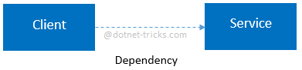
Let’s take another example of relationship between a client and a supplier. A client is dependent on the supplier for supplying products. If the supplier will not supply the products, client cannot use those products.

Understanding Inheritance and Different Types of Inheritance
Inheritance is a mechanism of acquiring the features and behaviors of a class by another class. The class whose members are inherited is called the base class, and the class that inherits those members is called the derived class. Inheritance implements the IS-A relationship.
For example, mammal IS-A animal, dog IS-A mammal; Hence dog IS-A animal as well.

Advantages
- Reduce code redundancy.
- Provides code reusability.
- Reduces source code size and improves code readability.
- Code is easy to manage and divided into parent and child classes.
- Supports code extensibility by overriding the base class functionality within child classes.

Disadvantages
- In Inheritance base class and child classes are tightly coupled. Hence If you change the code of parent class, it will get affects to the all the child classes.
- In class hierarchy many data members remain unused and the memory allocated to them is not utilized. Hence affect performance of your program if you have not implemented inheritance correctly.

Different Types of Inheritance
OOPs supports the six types of inheritance as given below-
    - Single inheritance
In this inheritance, a derived class is created from a single base class.
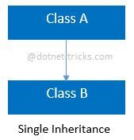
  - //Base Class
  - class A
  - {
  - public void fooA()
  - {
  - //TO DO:
  - }
  - }

  - //Derived Class
  - class B : A
  - {
  - public void fooB()
  - {
  - //TO DO:
  - }
  - }
    - Multi-level inheritance
In this inheritance, a derived class is created from another derived class.
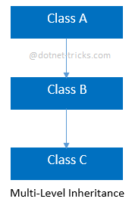
  - //Base Class
  - class A
  - {
  - public void fooA()
  - {
  - //TO DO:
  - }
  - }

  - //Derived Class
  - class B : A
  - {
  - public void fooB()
  - {
  - //TO DO:
  - }
  - }

  - //Derived Class
  - class C : B
  - {
  - public void fooC()
  - {
  - //TO DO:
  - }
  - }
    - Multiple inheritance
In this inheritance, a derived class is created from more than one base class. This inheritance is not supported by .NET Languages like C#, F# etc.
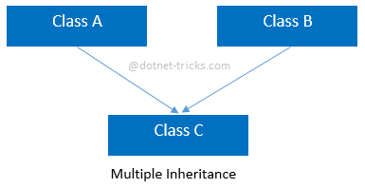
  - //Base Class
  - class A
  - {
  - public void fooA()
  - {
  - //TO DO:
  - }
  - }

  - //Base Class
  - class B
  - {
  - public void fooB()
  - {
  - //TO DO:
  - }
  - }

  - //Derived Class
  - class C : A, B
  - {
  - public void fooC()
  - {
  - //TO DO:
  - }
  - }
    - Multipath inheritance
In this inheritance, a derived class is created from another derived classes and the same base class of another derived classes. This inheritance is not supported by .NET Languages like C#, F# etc.
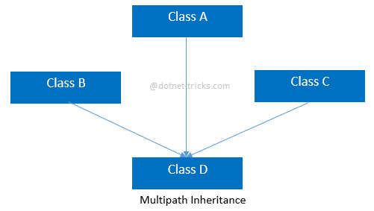
  - //Base Class
  - class A
  - {
  - public void fooA()
  - {
  - //TO DO:
  - }
  - }

  - //Derived Class
  - class B : A
  - {
  - public void fooB()
  - {
  - //TO DO:
  - }
  - }

  - //Derived Class
  - class C : A
  - {
  - public void fooC()
  - {
  - //TO DO:
  - }
  - }

  - //Derived Class
  - class D : B, A, C
  - {
  - public void fooD()
  - {
  - //TO DO:
  - }
  - }
    - Hierarchical inheritance
In this inheritance, more than one derived classes are created from a single base.
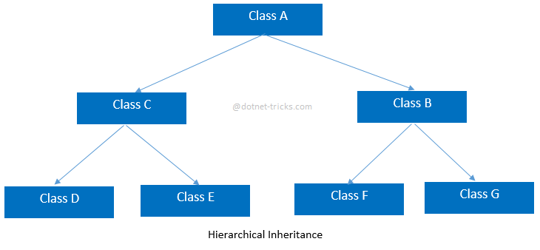
  - //Base Class
  - class A
  - {
  - public void fooA()

  - {
  - //TO DO:
  - }
  - }

  - //Derived Class
  - class B : A
  - {
  - public void fooB()
  - {
  - //TO DO:
  - }
  - }

  - //Derived Class
  - class C : A
  - {
  - public void fooC()
  - {
  - //TO DO:
  - }
  - }

  - //Derived Class
  - class D : C
  - {
  - public void fooD()
  - {
  - //TO DO:
  - }
  - }

  - //Derived Class
  - class E : C
  - {
  - public void fooE()
  - {
  - //TO DO:
  - }
  - }

  - //Derived Class
  - class F : B
  - {
  - public void fooF()
  - {
  - //TO DO:
  - }
  - }

  - //Derived Class
  - class G :B
  - {
  - public void fooG()
  - {
  - //TO DO:
  - }
  - }
    - Hybrid inheritance
This is combination of more than one inheritance. Hence, it may be a combination of Multilevel and Multiple inheritance or Hierarchical and Multilevel inheritance or Hierarchical and Multipath inheritance or Hierarchical, Multilevel and Multiple inheritance.
Since .NET Languages like C#, F# etc. does not support multiple and multipath inheritance. Hence hybrid inheritance with a combination of multiple or multipath inheritance is not supported by .NET Languages.
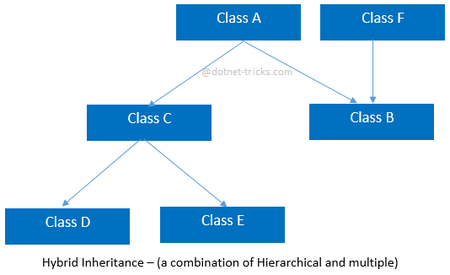
  - //Base Class
  - class A
  - {
  - public void fooA()
  - {
  - //TO DO:
  - }
  - }

  - //Base Class
  - class F
  - {
  - public void fooF()
  - {
  - //TO DO:
  - }
  - }

  - //Derived Class
  - class B : A, F
  - {
  - public void fooB()
  - {
  - //TO DO:
  - }
  - }

  - //Derived Class
  - class C : A
  - {
  - public void fooC()
  - {
  - //TO DO:
  - }
  - }

  - //Derived Class
  - class D : C
  - {
  - public void fooD()
  - {
  - //TO DO:
  - }
  - }

  - //Derived Class
  - class E : C
  - {
  - public void fooE()
  - {
  - //TO DO:
  - }
  - }

Difference Between Generalization and Specialization
The process of extracting common characteristics from two or more classes and combining them into a generalized superclass, is called Generalization. The common characteristics can be attributes or methods. Generalization is represented by a triangle followed by a line.

Specialization is the reverse process of Generalization means creating new sub classes from an existing class.
Let’s take an example of Bank Account; A Bank Account is of two types – Current Account and Saving Account. Current Account and Saving Account inherits the common/ generalized properties like Account Number, Account Balance etc. from a Bank Account and also have their own specialized properties like interest rate etc.
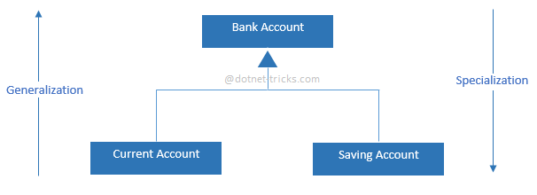

Introduction to LINQ
LINQ stands for Language-Integrated Query. Basically LINQ address the current database development model in the context of Object Oriented Programming Model. If some one wants to develop database application on .Net platform the very simple approach he uses ADO.Net. ADO.Net is serving as middle ware in application and provides complete object oriented wrapper around the database SQL. So developer must have good knowledge of object oriented concept as well as SQL to develop an application. But incase of Linq SQL statements are become part of the C# and VB.Net code so there are less chance of mistake.
LINQ enables developers to query data sources using a query like syntax with both C# and VB.NET. Using LINQ we can query any database and collection.

LINQ Flavors
    - LINQ to Objects
It provides the facility to query any kind of C# in-memory objects, like as arrays, lists, generic list and other collection types.LINQ to object query returns IEnumerable collection. It provides a new approach to query collection with powerful filtering, ordering and grouping capablities with minimum code.
    - LINQ to Ado.Net
LINQ to ADO.NET includes different flavors of LINQ to query data from different databases like as Microsoft SQL Server, Oracle, and others. It has following flavours
    - LINQ to SQL
It is specifically designed for working with Sql Server database. It provides run-time infrastructure for managing relational data as objects. It also supports transactions, views and stored procedures. It is an object-relational mapping (ORM) framework that allow 1-1 mapping of Sql Server database to .net classes. In this mapping the classes that match the database table are created automatically from the database itself and we can use these classes immediately.
    - LINQ to DataSet
It is an easy and faster way to query data cached in a DataSet object. It also allow LINQ to query over any database that can be query with Ado.Net.
    - LINQ to Entities
In many ways it is very similar to LINQ to SQL. It uses a conceptual Entity Data Model (EDM). The ADO.NET Entity Framework has been improved in .NET framework 4.0 to query any database like Sql Server, Oracle, MySql, DB2 and many more.
    - LINQ to XML
It provides an improved XML programming interface. Using this we can query, modify xml document and also save document after modification. System.Xml.Linq namespace contains classes for LINQ to XML.
    - PLINQ (Parallel LINQ)
PLINQ was introduced in .Net framework 4.0. It extends LINQ to Objects with a new parallel programming library. Using this, we can break/split up a query to execute simultaneously/parallel on different processors.

Summary
In this article I try to explain the different flavors of LINQ. Now, you can use LINQ according to your need and database. I would like to have feedback from my blog readers. Please post your feedback, question, or comments about this article.

Introduction to N-hibernate
NHibernate is a .NET based object persistence library for relational databases. Basically it is a framework that allows us to talk to a relational database in an object-oriented way. We can store/persist objects in a database and load those objects from the database later on. NHibernate automatically translates our programming language syntax to a language that the database understands. NHibernate also generates the required SQL statements to fetch, insert, update and delete data.
If we use NHibernate, then we never have to write any code that deals with the fact that there is an impedance mismatch between the way we develop applications in .NET and how a database works. NHibernate has abstracted away this mismatch for us.

What is O/RM?
O/RM is an acronym that stands for object/relational mapping. In a nutshell, an O/RM framework is used to persist model objects in a relational database and retrieve them. It uses metadata information to interface with the database. This way, your data-layer code knows nothing about the database structure; the O/RM tool becomes middleware that completely hides the complexity.
The heart of an O/RM is the mapping. Basically mapping technique binds the object and relational worlds. By mapping, we express how a class and its properties are related to one or more tables in the database. This information is used by the O/RM tool engine to build SQL code to retrieve data and transforms it into objects. The mapping information is generally expressed as an XML file. As an alternative, some O/RM tools use attributes on the classes and their properties to maintain mapping data.

Why NHibernate?
In the past, we carefully hand-crafted our data access layers for the applications we wrote. We spent as much as 50% or more of our overall time to implement and maintain this data layer.It was not a very challenging task though, and a lot of repetitive coding was involved.
As we were not the only developers facing the problem of writing the data access code,some people started to write and publish a framework that would solve this problem. This was the birth of the ORM frameworks such as NHibernate. Nowadays, accessing relational data from an object-oriented application is a solved problem
Thus, writing your own data layer is a waste of time. Somebody even used a much more pronounced phrase to pinpoint this fact, "Writing your own data access layer is like stealing money from your client".

Installing NHibernate
NHibernate is an open source project (OSS). Thus, the code and/or the binaries are freely available and can be downloaded from SourceForge. Before you can start coding, you must first install NHibernate. The following list presents a couple of blogs that are either mostly dedicated to NHibernate or contain a lot of information around this framework:
- The latest version of NHibernate can be downloaded from http://sourceforge.net/projects/nhibernate
- NHibernate meta blog at http://nhforge.org/blogs/nhibernate
- Fabio Maulo's blog at http://fabiomaulo.blogspot.com Fabio is the leader of the NHibernate project.
- James Gregory's blog at http://jagregory.com. James is the leader of the Fluent NHibernate project.

Once you’ve downloaded and installed NHibernate, you’re ready to create a new solution and start using it.

Introduction to Fluent Nhibernate
Fluent Nhibernate is a great O/RM tool to specify strongly typed mapping in the form of classes on the top of NHibernate framework. Fluent Nhibernate offers a simplified implementation of Nhibernate without using the XML(hbm) mapping files.Fluent NHibernate lets you write mappings in strongly typed C# code.
fluent nhibernate also provides the option for you to do an automapping where the mapping is automaticaly created and managed by fluent nhibernate.Creating Fluent Nhibernate automapping is pretty much straight forward in OneToOne, OneTomany relationship , but when it comes to ManyToMany relationship it is not easy.

Nhibernate Configuration files issues
The most important complains I personally have on NHibernate configuration files are:
- It is error prone.
- Errors in configuration file can be hard to trace.
- It is not refactoring friendly.

Fluent NHibernate Tools
    - Auto mapping
Fluent NHibernate automatically mapping all your entities based on a set of conventions.By using the auto mappings, you can map your entire domain with very little code, and certainly no XML.
    - Persistence specification testing
It provides a round-trip testing for your entities, without ever having to write a line of code. You can quickly test your mappings using the PersistenceSpecification class.
    - Fluent configuration
Fluent NHibernate provides an API to configure NHibernate for use with your application
    - Database configuration
Fluent NHibernate provides an API for configuring your database, this can be used in combination with the fluent configuration or on it's own.

Installing Fluent NHibernate
Fluent NHibernate is an open source project (OSS). Thus, the code and/or the binaries are freely available and can be downloaded from Github. Before you can start coding, you must first download Fluent NHibernate libraries that can be found here: http://fluentnhibernate.org/ .Unzip downloaded file and extract it into a folder of your choice.
Now start Visual Studio and create new web application project. Now you need to add references of Fluent NHibernate dll to your project. Right click on the References in your solution explorer and select Add Reference. Now browse the directory where you have extracted your Fluent NHibernate libraries and reference the following dll files:
- FluentNhibernate.dll
- NHibernate.dll
- NHibernate.ByteCode.Castle
Now you can continue to work on your web application with fluent nhibernate mapping to the database using strongly typed C# classes.

Introduction to Entity Framework
ADO.NET Entity Framework is an Object/Relational Mapping (ORM) framework that enables developers to work with relational database. It enabling developers to deal with data as objects and properties.Using the Entity Framework, developers issue queries using LINQ, then retrieve and manipulate data as strongly typed objects using C# or VB.Net.
The Entity Framework’s ORM implementation also provides services like change tracking, identity resolution, lazy loading, and query translation so that developers can focus on their application-specific business logic rather than the data access fundamentals. ADO.NET Entity Framework is targeted for developing Enterprise applications which can support MS SQL databases as well as other databases like as Oracle, DB2, MySql and many more. To learn entity framework first we need to know what is orm. I am going to give the overview of orm.

What is O/RM?
O/RM is an acronym that stands for object/relational mapping. Basically, an O/RM framework is used to persist model objects in a relational database and retrieve them. It uses metadata information to interface with the database. This way, your data-layer code knows nothing about the database structure. The O/RM tool becomes middleware that completely hides the complexity.
The heart of O/RM is the mapping—the mapping technique is what binds the object and relational worlds. By mapping, you express how a class and its properties are related to one or more tables in the database. This information is used by the O/RM tool’s engine to dynamically build SQL code that retrieves data and transforms it into objects. Similarly, by tracking changes to objects’ properties, it can use mapping data to send updates back to the database. The mapping information is generally expressed as an XML file. As an alternative, some O/RM tools use attributes on the classes and their properties to maintain mapping data.

Advantage of Entity Framework
- Productivity
Entity Framework can take up to 35 percent of the entire application code. It make the developer’s life easier than ever. In spite of its limitations, the designer integrated into Visual Studio dramatically simplifies the mapping process.
- Maintainability
Since you have the fewer lines of code to fetch data from database,the fewer lines of code you have to maintain. This is particularly true in the big projects.
- Performance
The complexity of O/RM introduces an obvious slowdown in performance. In entity framework first request to fetch data is little bit slow but after that is fast to fetch data from database.

Entity Framework Models
Microsoft’s Entity Framework evolved from a methodology known as Entity Relationship Modeling (ERM). An ERM defines a schema of entities and their relationships with one another. Entities are not the same as objects. Entities define the schema of an object, but not its behavior. So, an entity is something like the schema of a table in your database, except that it describes the schema of your business objects. There are three models in the entity framework:
- CONCEPTUAL MODEL
The conceptual model is where you describe the model classes. This file is split into two main sections: the first is a container that lists all the entities and the relationships that are managed by Entity Framework, and the second contains a detailed description of their structure.
- STORAGE MODEL
The storage model is the equivalent of the conceptual model, but it describes the database organization. Not only is this file conceptually similar to the previous one, but it also uses the same XML nodes. Unlike the conceptual model, it isn’t possible to split this model into several physical files. The first section of this file lists all the tables, views, stored procedures, and foreign keys that are affected. The second section describes the items listed in the first node.
Regarding tables and views, the columns and primary keys are described. When it comes to stored procedures, input and output parameters are described. The description of a foreign key contains information about the table involved, the cardinality, and the delete and update rules.
- MAPPING MODEL
The mapping file is completely different. Its job isn’t to describe something but to compensate for the differences that exist between the two previous models. This is where the real magic of mapping happens: you map a class to one or multiple tables, map one table to one or multiple classes, define inheritance mapping, and map stored procedures for both updates and object retrieval.
There is only one important node in this file: it associates the class to a table and can be repeated more than once to ensure that a class can be mapped against multiple tables, and vice versa. Like the storage description file and unlike the conceptual file, the mapping file can’t be split into multiple files.

Introduction to ASP.NET MVC
ASP.NET MVC is a new web application framework from Microsoft. MVC stands for Model-View-Controller, a pattern that’s becoming increasingly popular with web development frameworks. ASP.NET MVC is an alternative and a complement to Web Forms, which means you won’t be dealing with pages and controls, postbacks or view state, or complicated ASP.NET event life cycle.
Basically, MVC is a framework methodology that divides an application's implementation into three component roles: models, views, and controllers. Hence in Asp.net MVC you need to play with controllers, actions, and views.

MVC Pattern
The Model-View-Controller (MVC) pattern is an adaptation of a pattern generated from the Smalltalk community in the 1970s by Trygve Reenskaug. It was popularized for use on the web with the advent of Ruby on Rails in 2003.
- Model
Models in a MVC based application are the components of the application that are responsible for maintaining state. Often this state is persisted inside a database for example: we might have a Product class that is used to represent order data from the Products table inside SQL.
- View
Views in a MVC based application are the components responsible for displaying the application's user interface. Typically this UI is created off of the model data for example: we might create an Product "Edit" view that surfaces textboxes, dropdowns and checkboxes based on the current state of a Product object.
- Controller
Controllers in a MVC based application are the components responsible for handling end user interaction, manipulating the model, and ultimately choosing a view to render to display UI. In a MVC application the view is only about displaying information - it is the controller that handles and responds to user input and interaction.

ASP.NET MVC Web Application Advantages
The ASP.NET MVC Framework is a new framework and have the following advantages over Web Forms approach (means over ASP.Net):
- Separation of concern
In ASP.NET MVC the application is divided to Model, View and Controller parts which make it easier to manage the application complexity.
- TDD
The ASP.NET MVC framework brings better support to test-driven development.
- Extensible and pluggable
ASP.NET MVC framework components were designed to be pluggable and extensible and therefore can be replaced or customized easier then Web Forms.
- Full control over application behavior
ASP.NET MVC framework doesn’t use View State or server based forms like Web Forms. This gives the application developer more control over the behaviors of the application and also reduces the bandwidth of requests to the server.
- ASP.NET features are supported
ASP.NET MVC framework is built on top of ASP.NET and therefore can use most of the features that ASP.NET include such as the providers architecture, authentication and authorization scenarios, membership and roles, caching, session and more.
- URL routing mechanism
ASP.NET MVC framework supports a powerful URL routing mechanism that helps to build a more comprehensible and searchable URLs in your application. This mechanism helps to the application to be more addressable from the eyes of search engines and clients and can help in search engine optimization.
The ASP.NET MVC simplifies the complex parts of ASP.net Web Forms without any compromise of the power and flexibility of ASP.NET platform. ASP.net MVC implements Model-View-Controller UI pattern for web application development that lets you allows to develop applications in a loosely couples manner. MVC pattern is separating the application in three parts- Model, View and Controller.

Introduction to WCF
WCF stands for Windows Communication Foundation. It is Microsoft's latest technology that enables applications in a distributed environment to communicate with each other.WCF is Microsoft's unified programming model for building service-oriented applications. It enables developers to build secure, reliable, transacted solutions that integrate across platforms and interoperate with existing.
WCF is an umbrella technology that covers ASMX web services, .NET remoting, WSE, Enterprise Service, and System.Messaging. It is designed to offer a manageable approach to distributed computing, broad interoperability, and direct support for service orientation. WCF supports many styles of distributed application development by providing a layered architecture.

ABC of Windows Communication Foundation
What are the ABCs of WCF? "ABC" stands for address, binding and contract.
- Address (Where)
It specifies the location of the service means, where the service is hosted. The service hosting URL may be like http://server/wcfService. Clients will use this location to communicate with your service.
- Binding (How)
It specifies how the client will communicate to the service. We have different protocols (like http,tcp,named pipe,msmq) for the WCF to communicate to the client.
- Contract (What)
It specifies what the service will do. For this purpose we have different contract like as Data Contract, Operation Contract, Message Contract, Fault Contract. I will discuss all these later.

WCF Hosting
A WCF service is a component that can be called by other applications. It must be hosted in an environment in order to be discovered and used by others. The WCF host is an application that controls the lifetime of the service. With .NET 3.0 and beyond, there are several ways to host the service.
- Self hosting
A WCF service can be self-hosted, which means that the service runs as a standalone application and controls its own lifetime. This is the most flexible and easiest way of hosting a WCF service, but its availability and features are limited.
- Windows services hosting
A WCF service can also be hosted as a Windows service. A Windows service is a process managed by the operating system and it is automatically started when Windows is started (if it is configured to do so). However, it lacks some critical features (such as versioning) for WCF services.
- IIS hosting
A better way of hosting a WCF service is to use IIS. This is the traditional way of hosting a web service. IIS, by nature, has many useful features, such as process recycling, idle shutdown, process health monitoring, message-based activation, high availability, easy manageability, versioning, and deployment scenarios. All of these features are required for enterprise-level WCF services.
- Windows Activation Services hosting
The IIS hosting method, however, comes with several limitations in the service-orientation world; the dependency on HTTP is the main culprit. With IIS hosting, many of WCF's flexible options can't be utilized. This is the reason why Microsoft specifically developed a new method, called Windows Activation Services, to host WCF services.
Windows Process Activation Service (WAS) is the new process activation mechanism for Windows Server 2008 that is also available on Windows Vista. WAS hosting is possible only with IIS 7.0.Additional WCF components also plug into WAS to provide message-based activation over the other protocols that WCF supports, such as TCP, MSMQ, and named pipes. This allows applications that use the non-HTTP communication protocols to use the IIS features such as process recycling, rapid fail protection, and the common configuration systems that were only available to HTTP-based applications.

Basics of SQL Commands
SQL commands are a set of instructions that are used to interact with the database like Sql Server, MySql, Oracle etc. SQL commands are responsible to create and to do all the manipulation on the database. These are also responsible to give/take out access rights on a particular database

Sql Commands Category
We have different sql commands for different-different purpose. We can grouped Sql Commands into five major categories depending on their functionality.
- Data Definition Language (DDL)
These SQL commands are used to create, modify, and drop the structure of database objects like table, view, procedure, indexes etc. In this category we have CREATE, ALTER, DROP and TRUNCATE commands.

Note
  - Only with DDL commands we need to write keyword (like table, procedure, view, index, function) with the syntax of command.
  - These commands are used to create/modify the structure of the database object.

Example
  - CREATE TABLE TABLE_NAME
  - (
  - COL1 VARCHAR(10),
  - COL2 VARCHAR(20),
  - );
  - --Here "TABLE" is a keyword that is used to create table "TABLE_NAME"
  - CREATE VIEW VIEW_NAME
  - AS
  - BEGIN
  - SELECT * FROM EMP_TABLE
  - END
  - --Here "VIEW" is a keyword that is used to create VIEW "VIEW_NAME"
- Data Manipulation Language (DML)
These SQL commands are used to store, modify, and delete data from database tables. In this category we have INSERT, UPDATE, and DELETE commands.
- Data Quiery Language (DQL)
These SQL commands are used to fetch/retrieve data from database tables. In this category we have only SEELCT command.
- Transaction Control Language (TCL)
These SQL commands are used to handle changes which affect the data in database. Basically we use these commands with in the transaction or to make a stable point during changes in database at which we can rollback the database state if required. In this category we have SAVEPOINT, ROLLBACK and COMMIT commands.
- Data Control Language (DCL)
These SQL commands are used to implement security on database objects like table,view,stored procedure etc. In this category we have GRANT and REVOKE commands.

Note
  - Grant Command: This command is used to give permission to specific users on specific database objects like table, view etc.
  - Revoke Command: This command is used to take out permission from specific users on specific database objects like table, view etc.

Different Types of SQL Keys
A key is a single or combination of multiple fields in a table. Its is used to fetch or retrieve records/data-rows from data table according to the condition/requirement. Keys are also used to create relationship among different database tables or views.

Types of SQL Keys
We have following types of keys in SQL which are used to fetch records from tables and to make relationship among tables or views.
    - Super Key
Super key is a set of one or more than one keys that can be used to identify a record uniquely in a table.Example : Primary key, Unique key, Alternate key are subset of Super Keys.
    - Candidate Key
A Candidate Key is a set of one or more fields/columns that can identify a record uniquely in a table. There can be multiple Candidate Keys in one table. Each Candidate Key can work as Primary Key.
Example: In below diagram ID, RollNo and EnrollNo are Candidate Keys since all these three fields can be work as Primary Key.
    - Primary Key
Primary key is a set of one or more fields/columns of a table that uniquely identify a record in database table. It can not accept null, duplicate values. Only one Candidate Key can be Primary Key.
    - Alternate key
A Alternate key is a key that can be work as a primary key. Basically it is a candidate key that currently is not primary key.
Example: In below diagram RollNo and EnrollNo becomes Alternate Keys when we define ID as Primary Key.
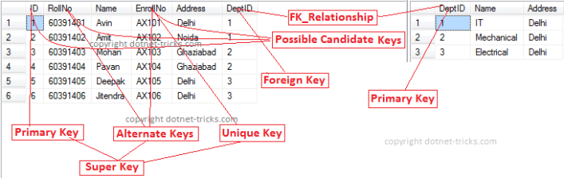
    - Composite/Compound Key
Composite Key is a combination of more than one fields/columns of a table. It can be a Candidate key, Primary key.
    - Unique Key
Uniquekey is a set of one or more fields/columns of a table that uniquely identify a record in database table. It is like Primary key but it can accept only one null value and it can not have duplicate values. For more help refer the article Difference between primary key and unique key.
    - Foreign Key
Foreign Key is a field in database table that is Primary key in another table. It can accept multiple null, duplicate values. For more help refer the article Difference between primary key and foreign key.
Example : We can have a DeptID column in the Employee table which is pointing to DeptID column in a department table where it a primary key.

Defining Keys in SQL Server
- --Department Table
- CREATE TABLE Department
- (
- DeptID int PRIMARY KEY, --primary key
- Name varchar (50) NOT NULL,
- Address varchar (200) NOT NULL
- )
- --Student Table
- CREATE TABLE Student
- (
- ID int PRIMARY KEY, --primary key
- RollNo varchar(10) NOT NULL,
- Name varchar(50) NOT NULL,
- EnrollNo varchar(50) UNIQUE, --unique key
- Address varchar(200) NOT NULL,
- DeptID int FOREIGN KEY REFERENCES Department(DeptID) --foreign key
- )

Note
  - Practically in database, we have only three types of keys Primary Key, Unique Key and Foreign Key. Other types of keys are only concepts of RDBMS which you should know.

SQL Integrity Constraints or Constraints
Constraints are some rules that enforce on the data to be enter into the database table. Basically constraints are used to restrict the type of data that can insert into a database table.Constraints can be defined in two ways:
  - Column Level
The constraints can be specified immediately after the column definition with the CREATE TABLE statement. This is called column-level constraints.
  - Table Level
The constraints can be specified after all the columns are defined with the ALTER TABLE statement. This is called table-level constraints.

Types of SQL Constraints
In Microsoft SQL Server we have six types of constraints
- Primary Key Constraints
Primary key is a set of one or more fields/columns of a table that uniquely identify each record/row in database table. It can not accept null, duplicate values.
Primary key constraint at column level
  - CREATE TABLE table_name
  - (
  - col1 datatype [CONSTRAINT constraint_name] PRIMARY KEY,
  - col2 datatype
  - );
Primary key constraint at table level
  - ALTER TABLE table_name
  - ADD[CONSTRAINT constraint_name] PRIMARY KEY (col1,col2)
- Unique Key Constraints
Unique key is a set of one or more fields/columns of a table that uniquely identify each record/row in database table.It is like Primary key but it can accept only one null value and it can not have duplicate values
Unique key constraint at column level
  - CREATE TABLE table_name
  - (
  - col1 datatype [CONSTRAINT constraint_name] UNIQUE,
  - col2 datatype
  - );
Unique key constraint at table level
- ALTER TABLE table_name
- ADD[CONSTRAINT constraint_name] UNIQUE (col1,col2)
- Foreign Key Constraints
Foreign Key is a field in database table that is Primary key in another table. It can accept multiple null, duplicate values.
Foreign key constraint at column level
  - CREATE TABLE table_name
  - (
  - col1 datatype [CONSTRAINT constraint_name] REFERENCES referenced_table_name(referenced_table_column_name),
  - col2 datatype
  - );
Foreign key constraint at table level
- ALTER TABLE table_name
- ADD[CONSTRAINT constraint_name] REFERENCES referenced_table_name(referenced_table_col)
- Not Null Constraints
This constraint ensures that all rows in the database table must contain value for the column which is specified as not null means a null value is not allowed in that column.
Not Null constraint at column level
  - CREATE TABLE table_name
  - (
  - col1 datatype [CONSTRAINT constraint_name] NOT NULL,
  - col2 datatype
  - );
Not Null constraint at table level
  - ALTER TABLE table_name
  - ALTER COLUMN col1 datatype NOT NULL
- Check Constraints
This constraint defines a business rule on a column in the database table that each row of the table must follow this rule.
Check constraint at column level
  - CREATE TABLE table_name
  - (
  - col1 datatype [CONSTRAINT constraint_name] CHECK (condition),
  - col2 datatype
  - );
Check constraint at table level
- ALTER TABLE table_name ADD CONSTRAINT constraint_name CHECK(condition)

Different Types of SQL Joins
Sql joins are used to fetch/retrieve data from two or more data tables, based on a join condition. A join condition is a relationship among some columns in the data tables that take part in Sql join. Basically data tables are related to each other with keys. We use these keys relationship in sql joins. Also, refer the article SQL Joins with C# LINQ.

Types of Joins
In Sql Server we have only three types of joins. Using these joins we fetch the data from multiple tables based on condition.
    - Inner Join
Inner join returns only those records/rows that match/exists in both the tables. Syntax for Inner Join is as
  - Select * from table_1 as t1
  - inner join table_2 as t2
  - on t1.IDcol=t2.IDcol
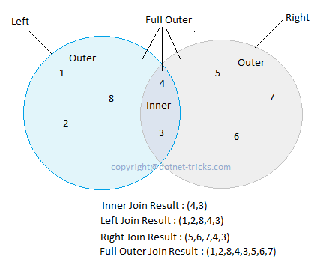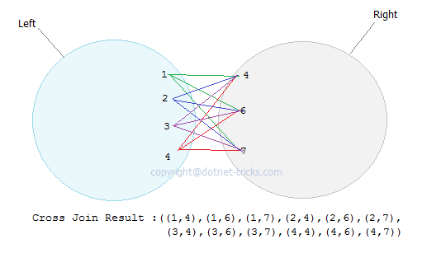
    - Outer Join
We have three types of Outer Join.
    - Left Outer Join
Left outer join returns all records/rows from left table and from right table returns only matched records. If there are no columns matching in the right table, it returns NULL values. Syntax for Left outer Join is as :
    - Select * from table_1 as t1
    - left outer join table_2 as t2
    - on t1.IDcol=t2.IDcol
- Right Outer Join
Right outer join returns all records/rows from right table and from left table returns only matched records. If there are no columns matching in the left table, it returns NULL values. Syntax for right outer Join is as :
    - Select * from table_1 as t1
    - right outer join table_2 as t2
    - on t1.IDcol=t2.IDcol
- Full Outer Join
Full outer join combines left outer join and right outer join. This join returns all records/rows from both the tables.If there are no columns matching in the both tables, it returns NULL values. Syntax for full outer Join is as :
    - Select * from table_1 as t1
    - full outer join table_2 as t2
    - on t1.IDcol=t2.IDcol
  - Cross Join
Cross join is a cartesian join means cartesian product of both the tables. This join does not need any condition to join two tables. This join returns records/rows that are multiplication of record number from both the tables means each row on left table will related to each row of right table. Syntax for right outer Join is as :
  - Select * from table_1
  - cross join table_2
  - Self Join
Self join is used to join a database table to itself, particularly when the table has a Foreign key that references its own Primary Key. Basically we have only three types of joins : Inner join, Outer join and Cross join. We use any of these three JOINS to join a table to itself. Hence Self join is not a type of Sql join.

Join Examples
Suppose we following three tables and data in these three tables is shown in figure. You can download the SQL script used in this article by using link.
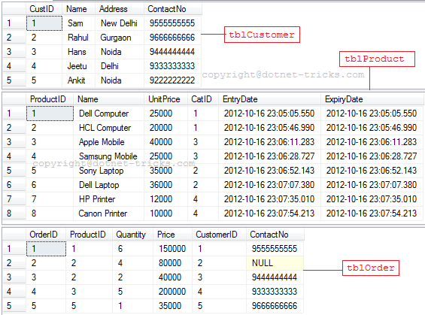

Inner Join
- SELECT t1.OrderID, t0.ProductID, t0.Name, t0.UnitPrice, t1.Quantity, t1.Price
- FROM tblProduct AS t0
- INNER JOIN tblOrder AS t1 ON t0.ProductID = t1.ProductID
- ORDER BY t1.OrderID
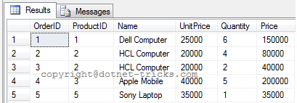

Inner Join among more than two tables
- SELECT t1.OrderID, t0.ProductID, t0.Name, t0.UnitPrice, t1.Quantity, t1.Price, t2.Name AS Customer
- FROM tblProduct AS t0
- INNER JOIN tblOrder AS t1 ON t0.ProductID = t1.ProductID
- INNER JOIN tblCustomer AS t2 ON t1.CustomerID = t2.CustID
- ORDER BY t1.OrderID
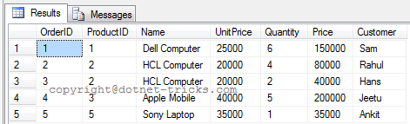

Inner Join on multiple conditions
- SELECT t1.OrderID, t0.ProductID, t0.Name, t0.UnitPrice, t1.Quantity, t1.Price, t2.Name AS Customer
- FROM tblProduct AS t0
- INNER JOIN tblOrder AS t1 ON t0.ProductID = t1.ProductID
- INNER JOIN tblCustomer AS t2 ON t1.CustomerID = t2.CustID AND t1.ContactNo = t2.ContactNo
- ORDER BY t1.OrderID
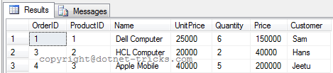

Left Outer Join
- SELECT t1.OrderID AS OrderID , t0.ProductID , t0.Name , t0.UnitPrice , t1.Quantity AS Quantity , t1.Price AS Price
- FROM tblProduct AS t0
- LEFT OUTER JOIN tblOrder AS t1 ON t0.ProductID = t1.ProductID
- ORDER BY t0.ProductID

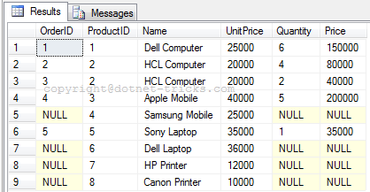

Right Outer Join
- SELECT t1.OrderID AS OrderID , t0.ProductID , t0.Name , t0.UnitPrice , t1.Quantity AS Quantity , t1.Price AS Price
- FROM tblProduct AS t0
- RIGHT OUTER JOIN tblOrder AS t1 ON t0.ProductID = t1.ProductID
- ORDER BY t0.ProductID
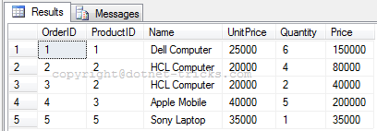

Full Outer Join
- SELECT t1.OrderID AS OrderID , t0.ProductID , t0.Name , t0.UnitPrice , t1.Quantity AS Quantity , t1.Price AS Price
- FROM tblProduct AS t0
- FULL OUTER JOIN tblOrder AS t1 ON t0.ProductID = t1.ProductID
- ORDER BY t0.ProductID
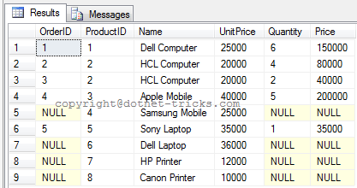

Cross Join
- SELECT t1.OrderID, t0.ProductID, t0.Name, t0.UnitPrice, t1.Quantity, t1.Price
- FROM tblProduct AS t0, tblOrder AS t1
- ORDER BY t0.ProductID
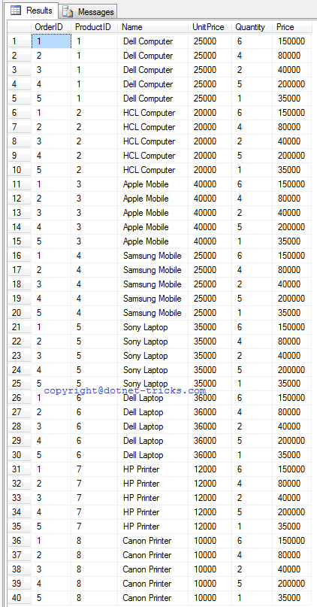

Self Join
To understand Self Join, suppose we following two tables and data in these two tables is shown in figure.
- CREATE TABLE emp
- (
- id int NOT NULL primary key,
- name varchar(100) NULL,
- designation varchar(50) NULL,
- supid int foreign key references emp(id) ) -- In this table we have a Foreign key supid that references its own Primary Key id. We use it for Self Join
- INSERT INTO emp(id,name,designation) VALUES(1,'mohan','Manger')
- INSERT INTO emp(id,name,designation,supid) VALUES(2,'raj kumar','SE',1)
- INSERT INTO emp(id,name,designation) VALUES(3,'bipul kumar','Manager')
- INSERT INTO emp(id,name,designation,supid) VALUES(4,'mrinal kumar','SE',2)
- INSERT INTO emp(id,name,designation,supid) VALUES(5,'jitendra kumar','SE',2)
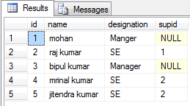
- CREATE TABLE empinfo
- (
- id int primary key,
- address varchar(50) NULL
- )
- INSERT INTO empinfo(id,address) VALUES(1,'Delhi')
- INSERT INTO empinfo(id,address) VALUES(2,'Noida')
- INSERT INTO empinfo(id,address) VALUES(4,'Gurgaon')
- INSERT INTO empinfo(id,address) VALUES(6,'Delhi')
- INSERT INTO empinfo(id,address) VALUES(7,'Noida')
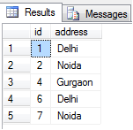
- select e.id,e.name,e.supid as managerid, ei.name as managername from emp e left join emp ei on e.supid=ei.id;
- -- outer keyword is optional
